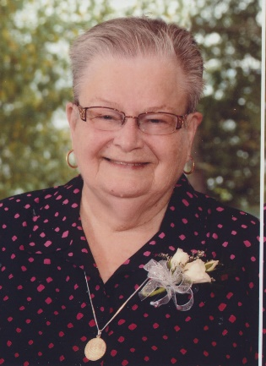
Obituary
Sister Cemonne Bigras
November 22, 1938 – May 30, 2020

It is with sadness that the Sisters of St. Joseph of Sault Ste. Marie, announce the death of Sister Cemonne Karlyn Bigras on Saturday, May 30, 2020 at the North Bay Regional Hospital.
Sister Cemonne was the only child of Phyllis (Wright) and Polydore (Paul) Joseph Bigras.
Cemonne had three wonderful children. She was predeceased by her son Jeffrey and daughter Donna. She is survived by her son Scott Drummond and grandsons, Cole and Riley.
For twenty three years Cemonne worked at Leigh Instruments Limited, Carleton Place, in the engineering and aerospace division.
Following studies in alcohol and drug addictions at Algonquin College, Ottawa, Cemonne relocated to Sudbury in 1986, where she worked as a counsellor for women at the Robins Hill Aftercare Services.
Sister Cemonne entered the congregation of The Sisters of St. Joseph, September 1, 1988. She then served in Sudbury and Sault Ste. Marie, in parish ministry and addiction counselling. In 1990 she served as addiction program coordinator at the John Howard Society, and worked at the Sudbury jail.
Cemonne ministered in Sudbury as a volunteer at St. Leonard’s Halfway House, with the Lesbian Gay Bisexual Transgendered Coalition and Lakeside Centre 5th Steps program. In 2002 she joined the Family Enrichment Centre as an addiction counsellor.
Sister Cemonne retired to the Motherhouse in 2016 where in spite of health challenges she continued to serve on congregational committees.
Cemonne was a kind, perceptive listening presence and wise counsellor to many. She enjoyed a myriad of hobbies and interests: music, fishing, crafts, reading and cooking. Her keen mind and playful disposition engaged others in conversation and debate.
During these unprecedented times, it is with regret that The Sisters of St. Joseph will not have a public funeral liturgy. A private service will be held and a Celebration of Sister Cemonne’s life will be scheduled at a later date.
In lieu of flowers, donations to the works and ministries of The Sisters of St. Joseph of Sault Ste. Marie would be appreciated. Online condolences can be made at www.hillsidefuneral.ca
Sister Cemonne Rest in Peace.

